

INFO 6105 Final Project

Daily News Classifier

**Team 23 – Batch 34274**

**Group Members:**

Aditya Kulkarni (NUID: 001001395)

Mohammed Saqlain Kazi (NUID: 001023485)

Contents

Introduction 3

Background 3

Objective 3

Methodology and Approach 4

News Article Data Cleaning 5

News Pre-processing 6

Feature Engineering 6

Data Visualization 8

Data Loading 9

Machine Learning Algorithms ...10

Multinomial Naïve Bayes (MNB) Classifier 12

Gaussian Naïve Bayes (GNB) Classifier ..........................................................................17

Random Forest Classifier 20

Support Vector Machine (SVM) Classifier 24

K-Nearest Neighbours (KNN) Classifier 31

Stochastic Gradient Descent (SGD) Classifier 35

Specifications of Dataset 39

Results and Analysis 40

Conclusion & Future Scope 41

References and resources 42

# Introduction

## Background

There is a significant volume of material contained in electronic format. With so much evidence, it has become essential to provide tools that can measure and evaluate it, as well as extract facts that can aid decision-making. At the beginning of the last decade, news content was not easily and rapidly available. However, internet outlets such as online news services also make news readily available. With the increase in the number of stories, it has become more difficult for consumers to find news of interest, necessitating the development of news categories so that it can be quickly viewed. Categorization is the process of grouping papers together to make navigation between them simpler. The news on the internet can be separated into groups. This will allow users to get real-time news on their interests without wasting time. Furthermore, with very little time on our hands, it is impossible to read the whole news summary. A summary of the entire news story would aid readers in not only saving time but also covering a greater number of posts in a shorter period. Summarization is where a long text is reduced to a quick summary or a short outline while maintaining the integrity and theme of the document.

## Objective

When it comes to reporting, it is much more difficult to categorize it because new stories are always circulating and must be always processed. The information could be unique and come into a new category. We used a Machine Learning approach to build a Daily News Classifier. The daily news classifier is an automatic news classification model that finds and categorizes untracked news topics. Six machine learning frameworks are implemented in our system. Machine learning is used to categorize the news stories that are fed into the dataset. The classifier uses the keywords derived from attributes like headlines as inputs to predict the relevant category for each new news story.

# Methodology and Approach

The classification of news involves several stages. Classification is a daunting task because it necessitates pre-processing steps to translate unstructured textual data into organized form. For the classification of news articles, the text classification method entails the following key stages. Data collection, pre-processing, feature selection, classification procedure implementation, and performance measurement evaluation are the steps involved.

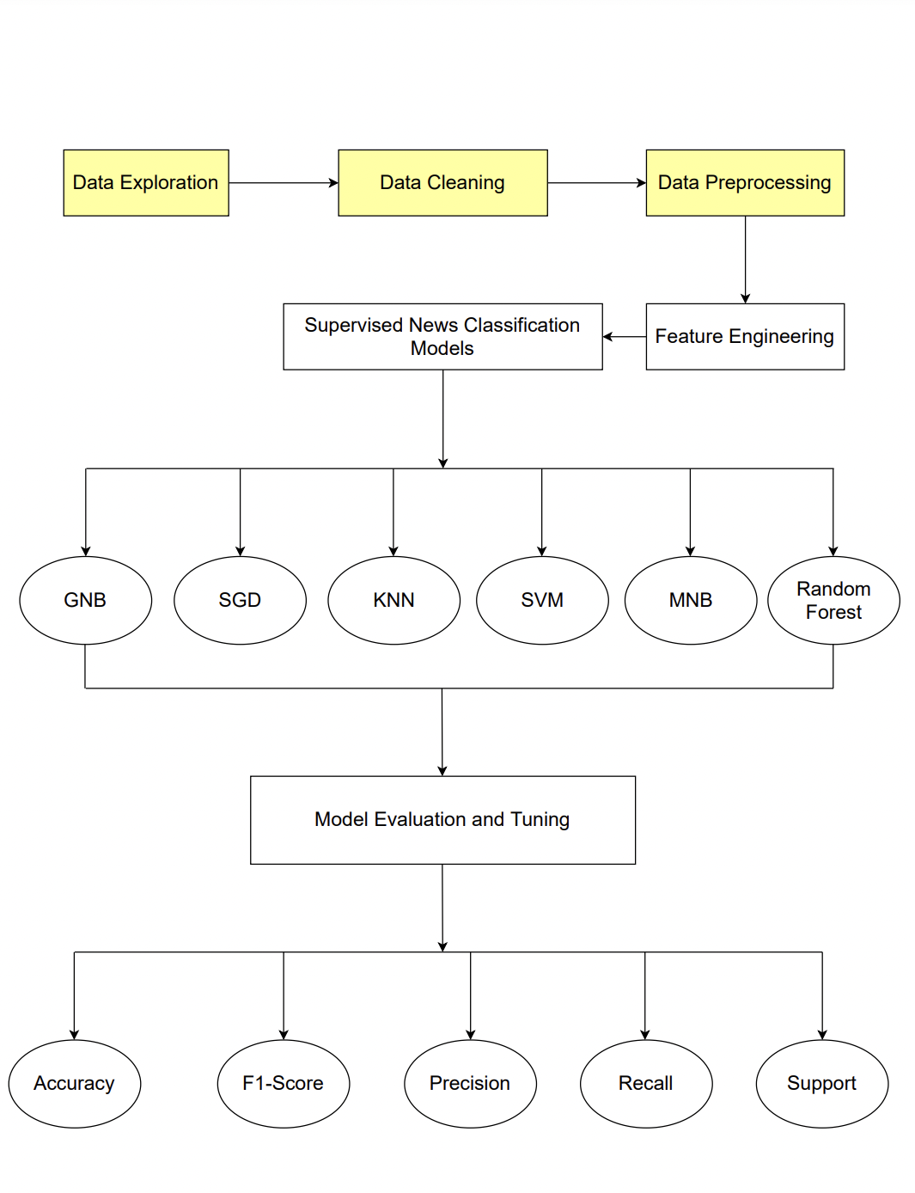

## News Article Data Cleaning

To ensure that no inconsistencies are added to the model, we must clean it before constructing any function from the raw text. We took the following steps:

* Special character and non ascii character cleaning: special characters such as “\n” double quotes must be removed from the text along with non ascii characters since we are not expecting any predicting power from them.
* Up case/down case: we would expect, for example, “Book” and “book” to be the same word and have the same predicting power. For that reason, we have downcased every word.
* Punctuation signs: characters such as “?”, “!”, “;” have been removed.
* Stop words: words such as “what” or “the” won’t have any predicting power since they will presumably be common to all the documents. For this reason, they may represent noise that can be eliminated. We have downloaded a list of English stop words from the nltk package and then deleted them from the corpus.

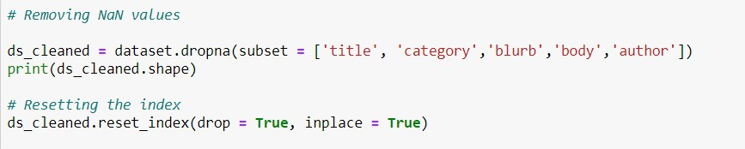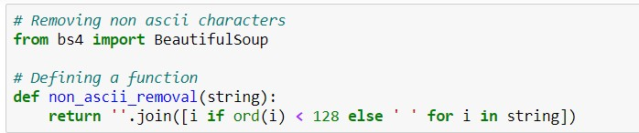

## 

## News Pre-processing

The transformations we apply to our data before feeding it to the algorithm are referred to as pre-processing. The raw data has been transformed into a clean data package. In other words, since the dataset includes data from several sources, the data is in raw format, making interpretation impossible. The format of the data must be in a proper fashion in order to achieve improved outcomes from the implemented paradigm in Machine Learning. Some Machine Learning models include data in a certain format; for example, the Random Forest algorithm does not accept null values; thus, null values must be handled from the initial raw data set in order to run the Random Forest algorithm. Another consideration is that the data set should be formatted in such a way that it can run several Machine Learning and Deep Learning algorithms in parallel, with the best of them being selected. As a result, we conducted data pre-processing on the raw dataset in order to make it safe and usable.

## Feature Engineering

When there are many features and each feature is a well-known descriptive word for each class, classification may take a long time and the expected accuracy cannot be achieved. To overcome these issues, a feature selection process is used in which only the most relevant and highly effective features are chosen, which can prove more accurate. Feature engineering is the method of converting data into features that can be used as inputs to machine learning algorithms, with the goal of optimizing model efficiency. There are many methods for accessing features that represent text data while working with it.

For function engineering, we made category clusters. There were approximately 170 categories that could not be considered core categories at the start. There are several general categories that may be used to group these 170 categories. As a result, we manually generated five clusters and applied all of the relevant groups to each of those five clusters. These are mainly -

* Entertainment
* Health and Technology
* Politics
* Crime
* Business and Finance

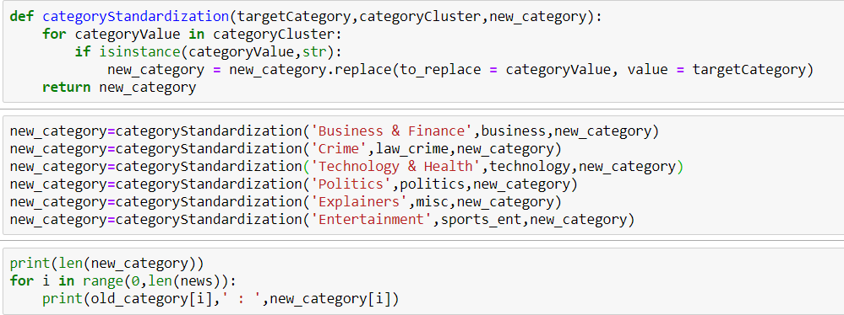

## Data Visualization

The dataset is categorized into five categories as depicted in the pie chart.

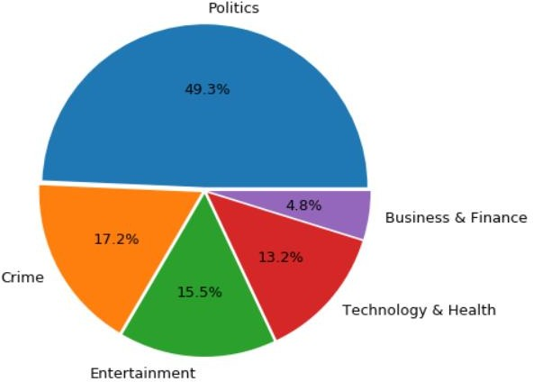

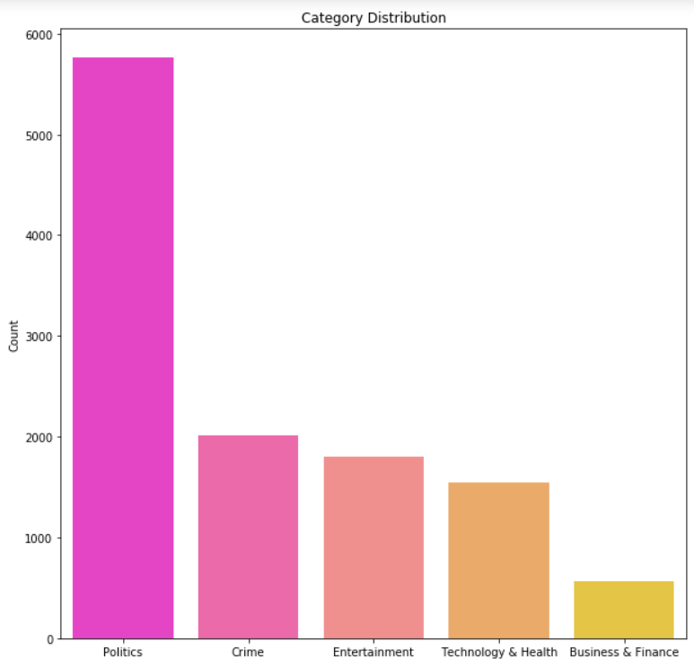

## Data Loading

The first step is to create a DataFrame and load the tsv format. As seen in the screenshot below, we have imported all of the requisite libraries. The first three rows of the dataset, as well as the target vector for the whole dataset, are printed.

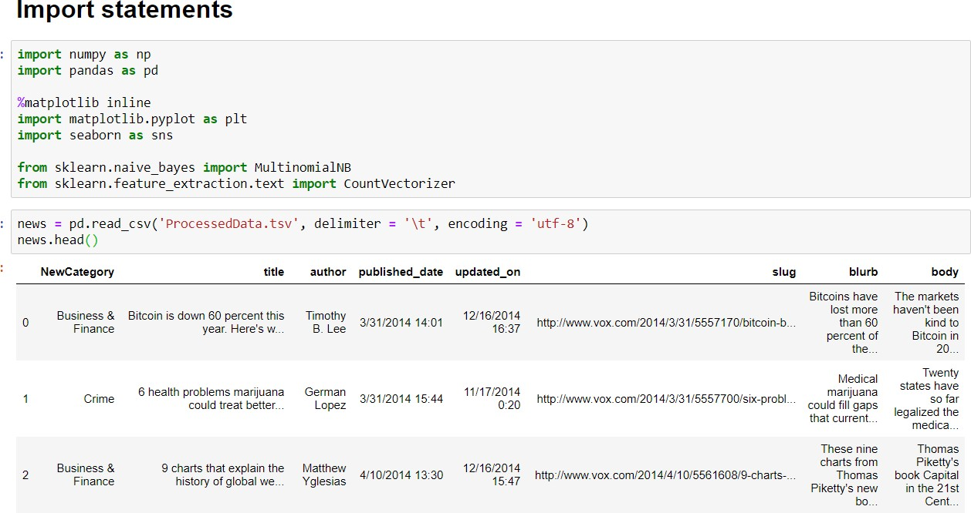

**Machine Learning Algorithms**

The classification process follows feature collection and is a vital phase in which the aim is to categorize the unknown news into their appropriate categories. Multinomial Naive Bayes, Random Forest, Support Vector Machines, K-Nearest Neighbors, and Stochastic Gradient Descent are the most popular news classification methods. In order to get the best results, we used the hyperparameter method in both models above.

We have used the following libraries in our system for the analysis:

* NumPy
* Pandas
* Scikit-Learn
* Matplotlib
* Seaborn

### NumPy

NumPy is a significant Python package for scientific computation. NumPy can also be used to store common data in a multi-dimensional container. Datatypes of any kind may be specified. This enables NumPy to work with a wide range of databases with ease and pace. We used NumPy in our project to translate confusion matrices to arrays so that we could plot confusion matrices for each model.

### Pandas

Pandas is an open source, BSD-licensed library for the Python programming language that provides high-performance, easy-to-use data structures and data analysis resources. It is based on the NumPy bundle, and the DataFrame is its primary data structure. DataFrames are a type of data structure that allows you to store and manipulate tabular data in the form of rows of observations and columns of variables. We used pandas to import a tsv file as a DataFrame, concatenate several data frames into a single DataFrame, and perform other technical tasks when creating the model in our project.

### SciKit-Learn

Support vector machines, random forests, Gaussian Naïve Bayes, Scalers, and KNN are all implemented using the Scikit-learn library. NumPy and SciPy, two Python numerical and science libraries, are also supported. This library was used in our project for model training and measuring model metrics such as accuracy and score.

### MatPlotLib

Matplotlib is a plotting library for Python and NumPy, the Python numerical mathematics extension. It offers an object-oriented API for using general-purpose GUI toolkits to integrate plots in applications. In our research, we use MatPlotLib to create a Bar Chart to visualize the distribution of news categories.

### Seaborn

Seaborn is a Python library for creating statistical graphics. It is based on matplotlib and is tightly combined with pandas data structures. Seaborn aspires to make visualization a key part in data exploration and comprehension. Its dataset-oriented plotting functions work for data frames and arrays comprising whole datasets, performing the requisite semantic mapping and statistical aggregation internally to generate insightful plots. We used seaborn to map groups against the count of news articles obtained from the dataset using bar charts.

Let us look at each model and see how it works.

## Multinomial Naïve Bayes (MNB) Classifier

The multinomial Naive Bayes classifier is suitable for classification with discrete features (e.g., word counts for text classification). The multinomial distribution normally requires integer feature counts. However, in practice, fractional counts such as tf-idf may also work. Naïve Bayes classifier is a simple probabilistic classifier based on applying Bayes Theorem with strong independence assumptions. This algorithm computes the posterior probability of the news belonging to different categories and it assigns news article to the category with the highest posterior probability. Bayesian theory works as a framework for making decision under uncertainty - a probabilistic approach to inference and is particularly suited when the dimensionality of the inputs data is high.

Bayes theorized that the probability of future events could be calculated by determining their earlier frequency. Bayes theorem states that:

P(Y=y_i |X=x_k )=(P(Y=y_i )|P(X=x_k |Y=y_i ))/P(X=x_k ) Where:

P(Y=y_i ) - Prior probability of hypothesis Y- Prior P(X=x_k ) - Prior probability of training data X-Evidence P(X=x_k |Y=y_i )- Probability of X given Y- Likelihood

P(Y=y_i |X=x_k )- Probability of Y given X- Posterior probability.

### Feature Extraction and Vectorization

The method of converting a series of text documents into numerical function vectors is known as vectorization. The Bag of Words or "Bag of n-grams" representation refers to this technique (tokenization, numbering, and normalization). Word instances are used to identify documents, but the relative location details of the terms in the text is entirely ignored. We transform a collection of text documents into a token count matrix.

Features and samples are defined as follows:

* Each individual token occurrence frequency (normalized or not) is treated as a feature.
* The vector of all the token frequencies for a given document is considered a multivariate sample

3 Steps for Vectorization are:

* Import
* Instantiate
* Fit and Transform

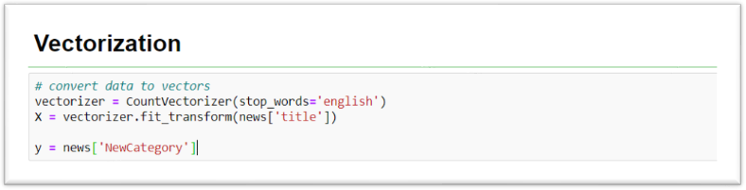

### Splitting the data and Training the model

First, we have separated the columns into dependent and independent variables (or features and label). Then we have split those variables into train and test set.

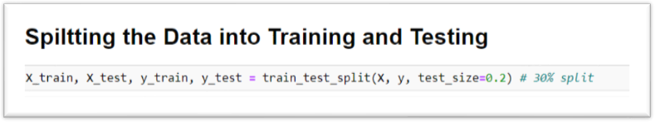

After splitting, we have generated a Multinomial Naïve Bayes model on the training set and performed prediction on test set features.

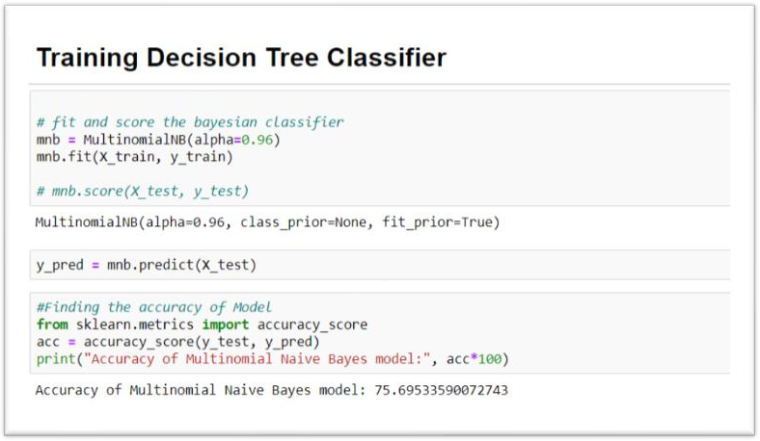

In order to enhance the performance, we would perform hyperparameter tuning. There are a few parameters we implicitly assumed when we did our training. In Multinomial Naive Bayes, the alpha parameter is what is known as a hyperparameter; i.e. a parameter that controls the form of the model itself. In most cases, the best way to determine optimal values for hyperparameters is through a grid search over possible parameter values, using cross validation to evaluate the performance of the model on your data at each value.

In our model, we changed the value of alpha parameter from 0.96 to 0.5. This modification led to increase in the accuracy of the model to 76.34%.

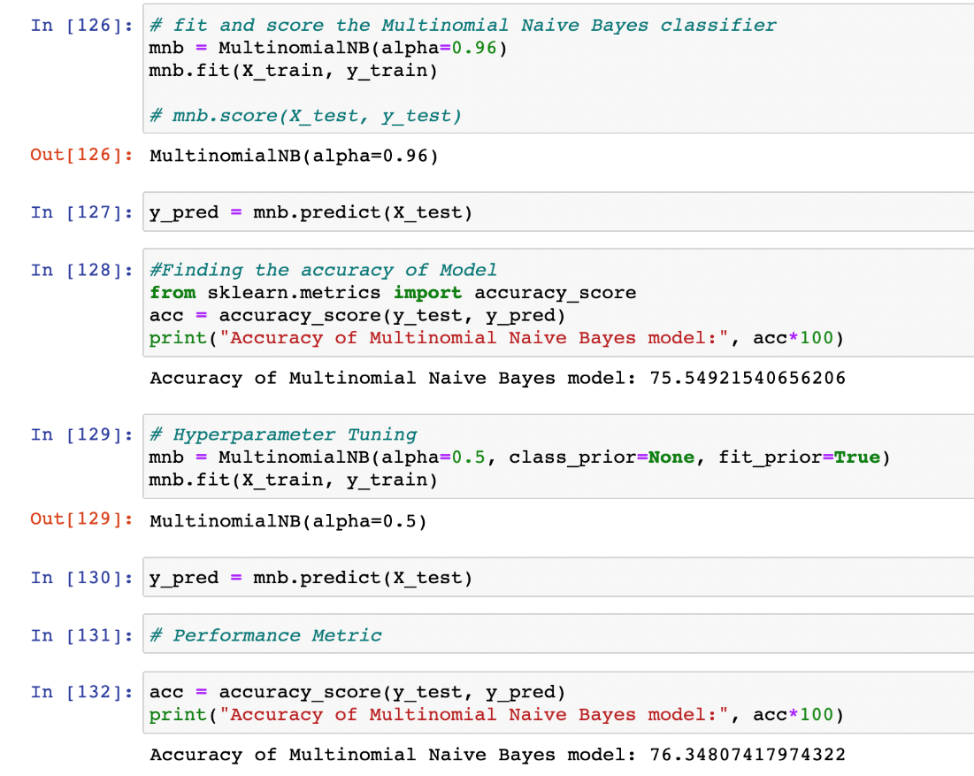

### Evaluating the model

We have evaluated the model using the classification report and confusion matrix. Classification report comprises of categories mapped against the model metrics such as F1 score, Recall, support, and Precision.

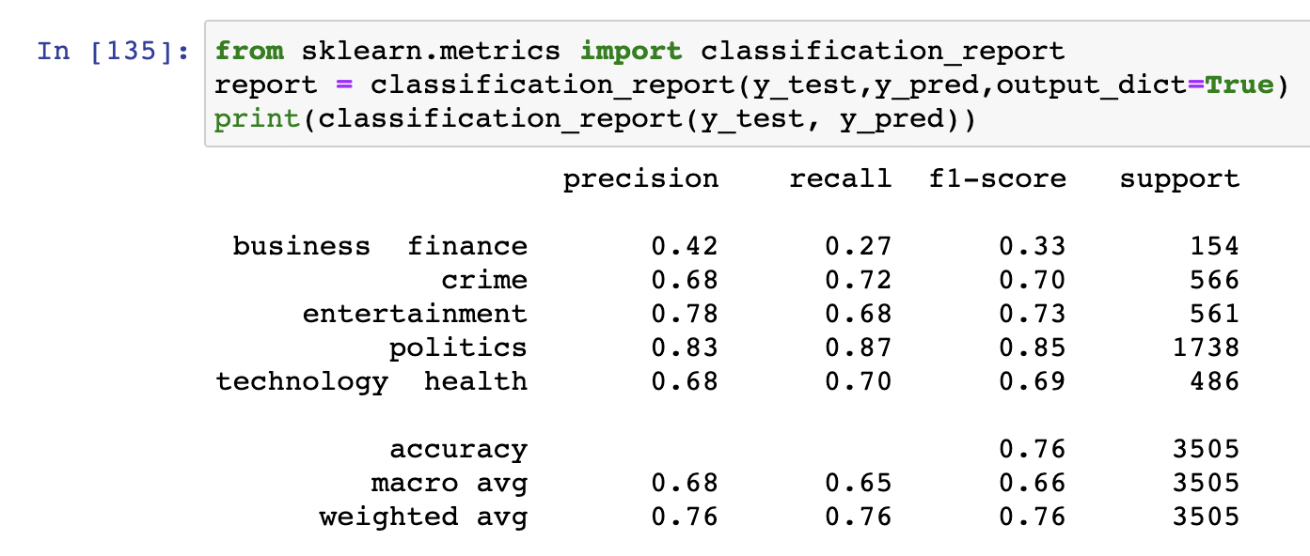

**Results for Multinomial Naïve Bayes model:**

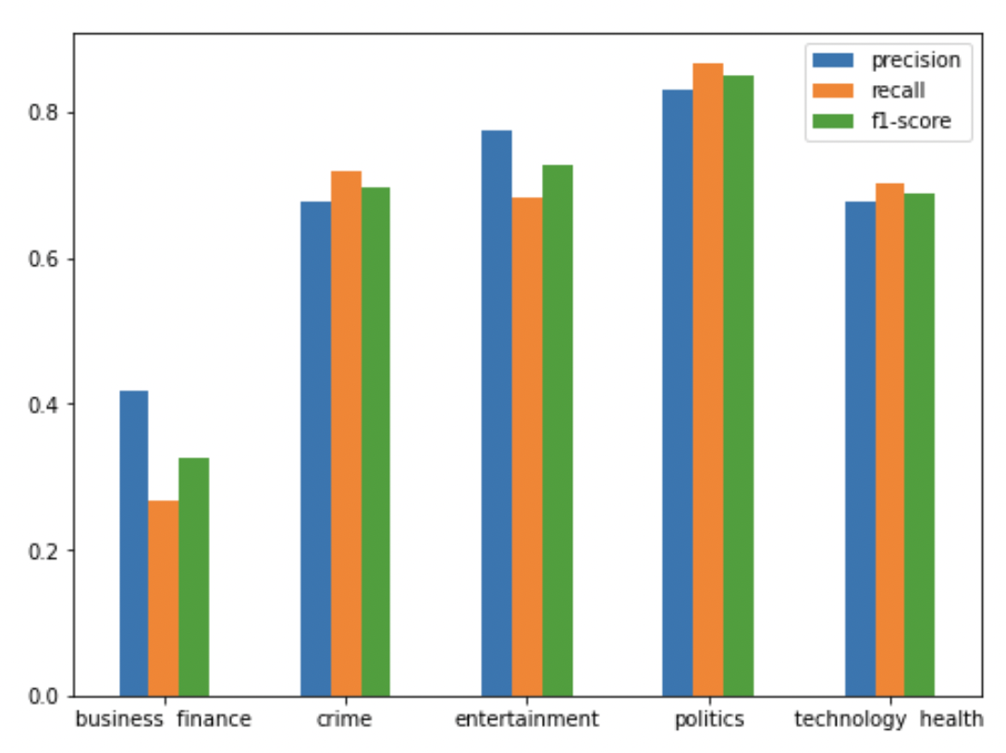

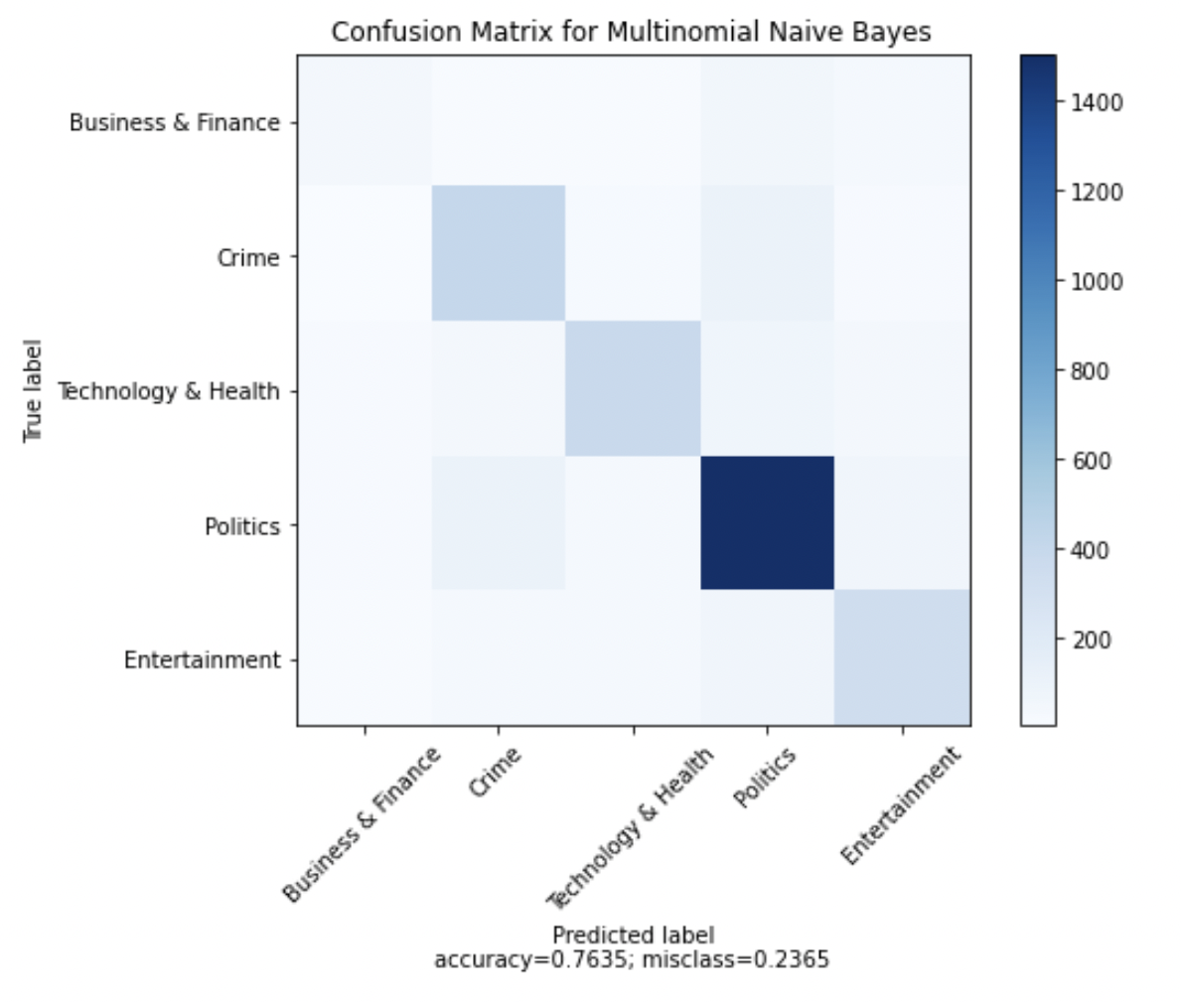

Gaussian Naïve Bayes (GNB) Classifier

[GaussianNB](https://scikit-learn.org/stable/modules/generated/sklearn.naive_bayes.GaussianNB.html#sklearn.naive_bayes.GaussianNB) implements the Gaussian Naive Bayes algorithm for classification. The likelihood of the features is assumed to be Gaussian:

Gaussian Naïve Bayes is a variant of NaiveBayes that follows Gaussian normal distribution and supports continuous data. NaiveBayes are a group of supervised machine learning classification algorithms based on the Bayes theorem. It is a simple classification technique but has high functionality.

When working with continuous data, it's common to assume that the continuous values associated with each class follow a regular (or Gaussian) distribution. Assume the training data has a continuous feature called displaystyle xx. The mean and variance of displaystyle xx in each class are computed after the data is segmented by class. Let displaystyle mu _kmu _k represent the mean of the values in displaystyle xx associated with class Ck, and displaystyle sigma _k2displaystyle sigma _k2 represent the Bessel corrected variance of the values in displaystyle xx associated with class Ck. Assume we've gathered some displaystyle vv observation values. The probability density of displaystyle vv given a class displaystyle C kC k, displaystyle p(x=vmid C k)displaystyle p(x=vmid C k)displaystyle p(x=vmid C k)displaystyle p(x=vmid C k), can then be computed by plugging displaystyle vv into the equation for a normal distribution parameterized by displaystyle mu kmu That is to say,

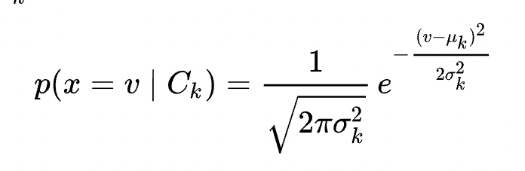

Another common technique for dealing with continuous values is and bin the feature values to create a new collection of Bernoulli-distributed features; some literature indicates that this is required to use naive Bayes, but it is not, and the discretization can throw away discriminative knowledge. (5)

The distribution of class-conditional marginal densities can be out of whack at times. Kernel density estimation can be used in these situations to provide a more accurate approximation of each class's marginal densities. This approach, which was first proposed by John and Langley[9], will significantly improve the classifier's accuracy.

After splitting, we have generated a Multinomial Naïve Bayes model on the training set and performed prediction on test set features.

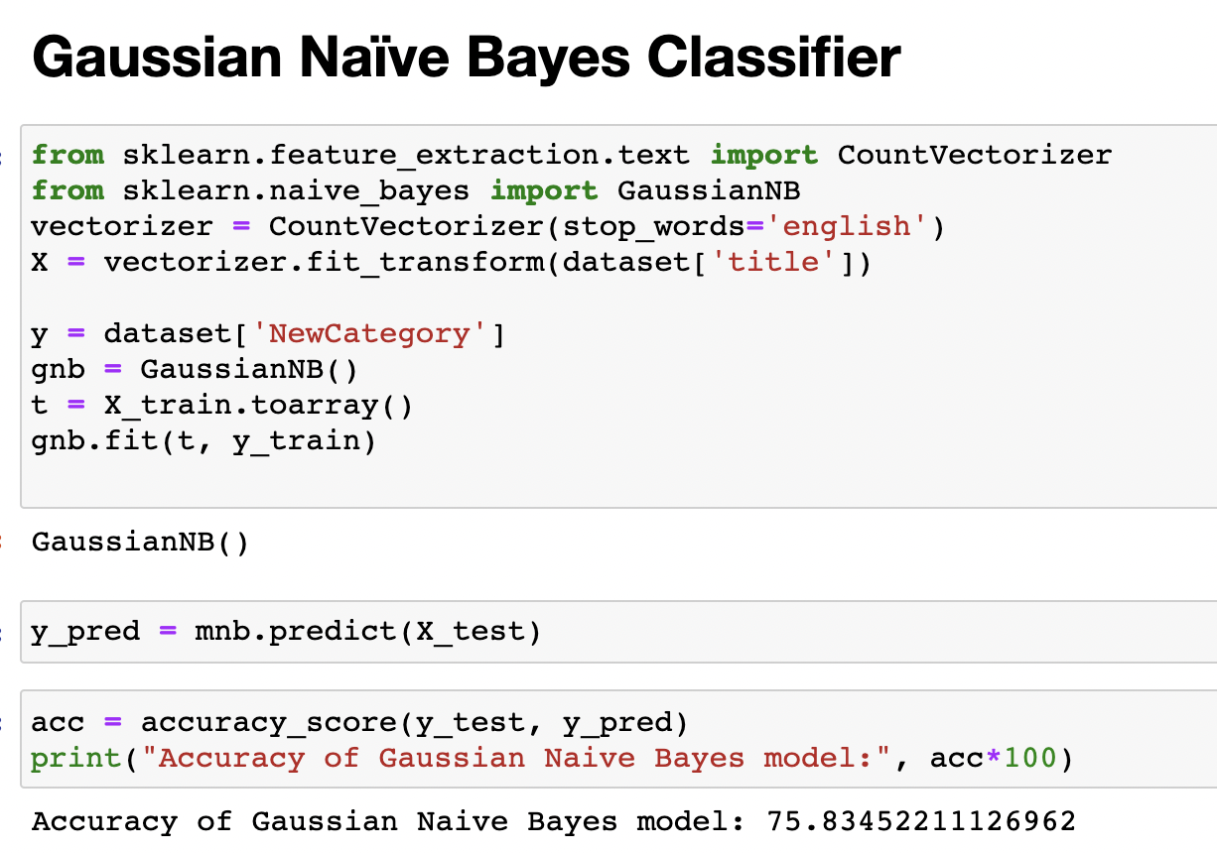

### Evaluating the model

We have evaluated the model using the classification report and confusion matrix. Classification report comprises of categories mapped against the model metrics such as F1 score, Recall, support and Precision.

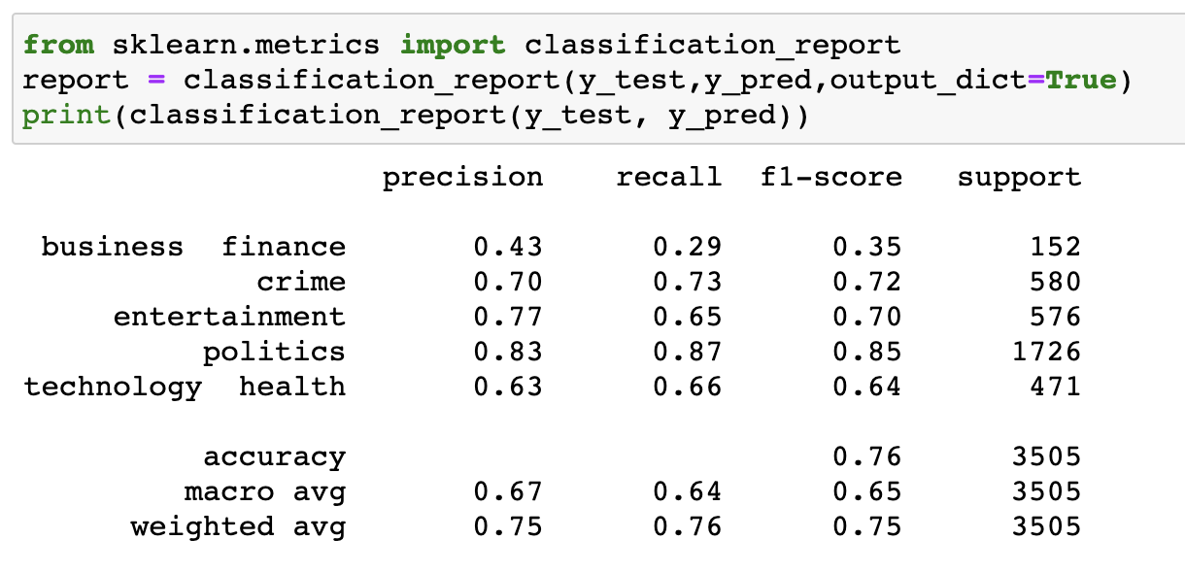

**Results for Gaussian Naïve Bayes model:**

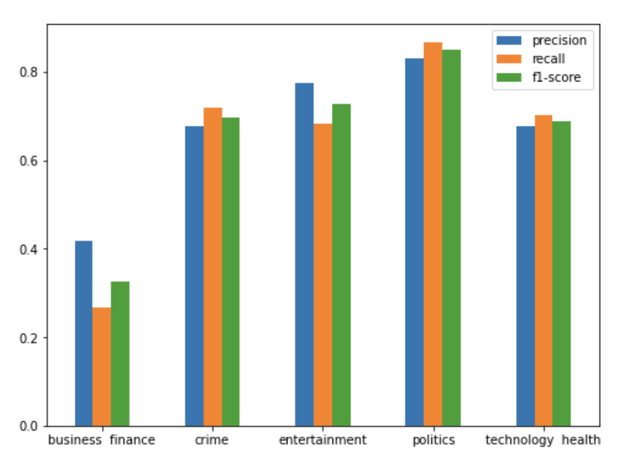

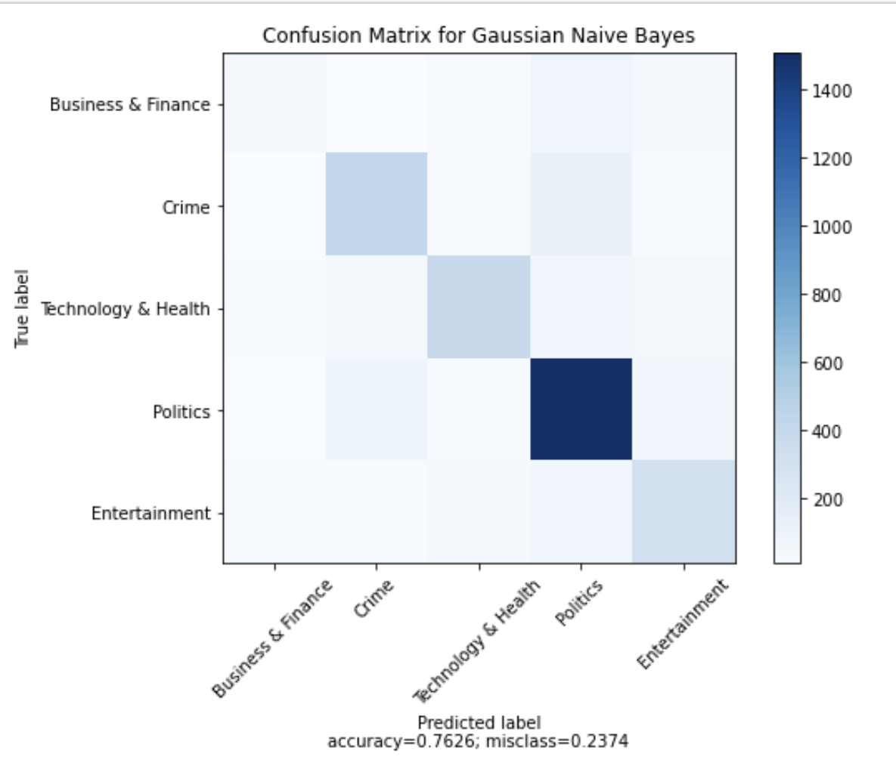

## Random Forest Classifier

Random Forest is a learning algorithm that is supervised. It can be used for both classification and regression. It is also the most adaptable and user-friendly algorithm. The trees make up a woodland. A forest is said to be more durable the more trees it has. Random forests build decision trees out of randomly chosen data samples, get predictions from each tree, and vote on the best solution. It also serves as a strong indicator of the value of the function. A random forest, in technical terms, is a meta estimator that fits a variety of decision tree classifiers on different sub samples of the data set and uses averaging to increase predictor precision and power over fitting. We believed that random forest would outperform decision trees as an ensemble system. We can use decision tree testing practice in addition to random forest.

### Feature Extraction and Vectorization

Random Forest, unlike other models, uses a numeric value to perform feature engineering. The initial dataset of our project had categories as text values. We factored the category column and translated it to category ids in order to carry out function engineering. Following that, the standard vectorization method was used to apply the bag of words solution.

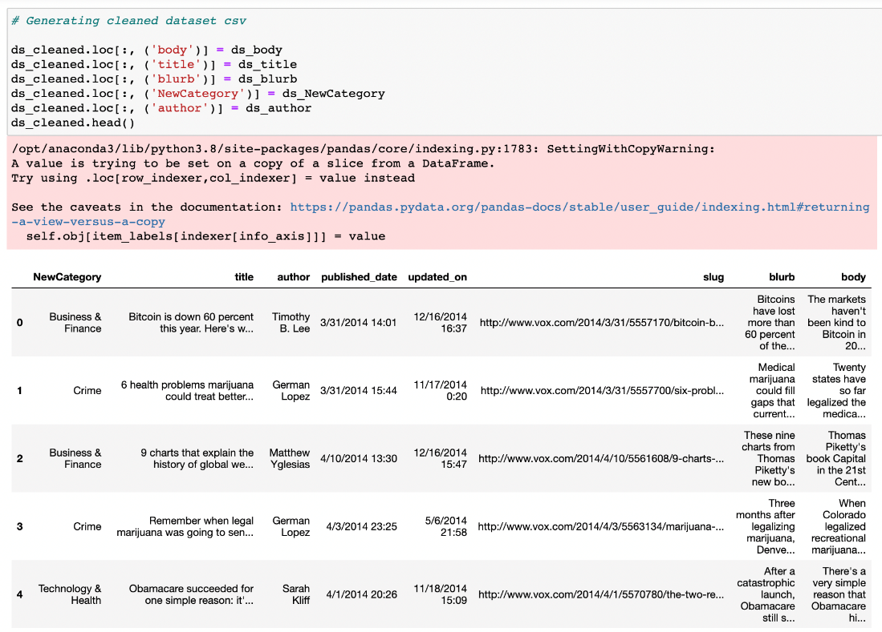

### Splitting the data and Training the model

First, we have separated the columns into dependent and independent variables (or features and label). Then we have split those variables into train and test set.

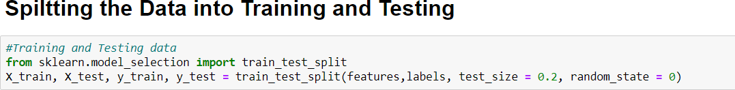

After splitting, we have generated Random Forest model on the training set and performed prediction on test set features.

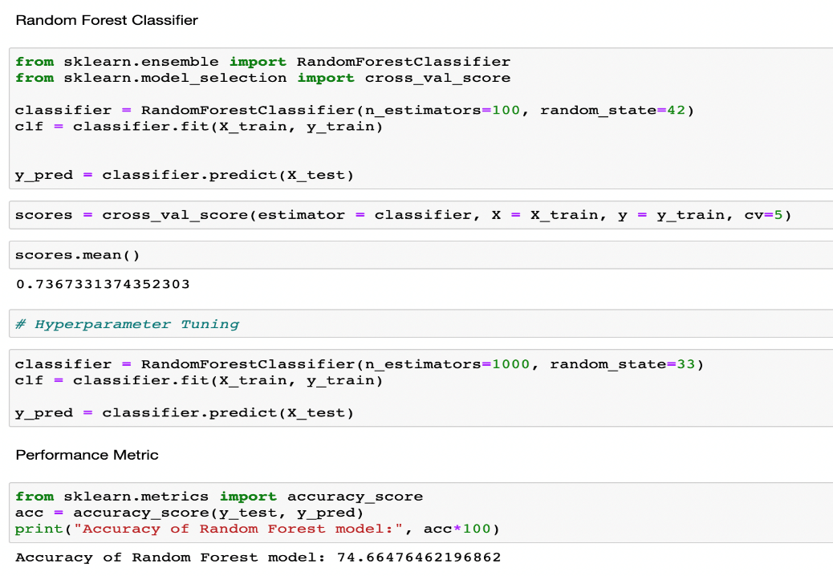

In order to enhance the performance, we would perform hyperparameter tuning. There are a few parameters we implicitly assumed when we did our training. In Random Forest model, n_estimators are the parameter on which hyperparameter tuning is performed. N_estimator denotes the number of trees in the forest. In most cases, the best way to determine optimal values for hyperparameters is through a grid search over possible parameter values, using cross validation to evaluate the performance of the model on your data at each value.

In our model, we changed the value of n_estimator parameter from 100 to 1000. This modification led to increase in the accuracy of the model to 74.66%.

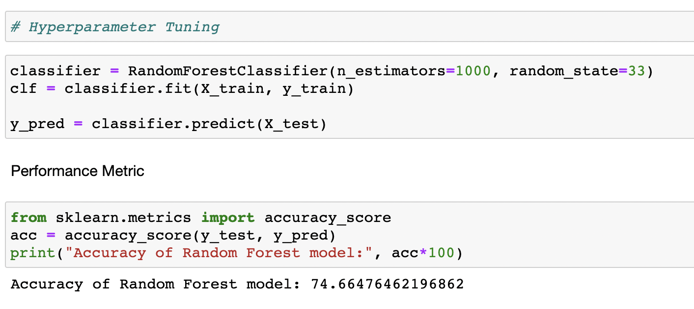

### Evaluating the model

We have evaluated the model using the classification report and confusion matrix. Classification report comprises of categories mapped against the model metrics such as F1 score, Recall, support and Precision.

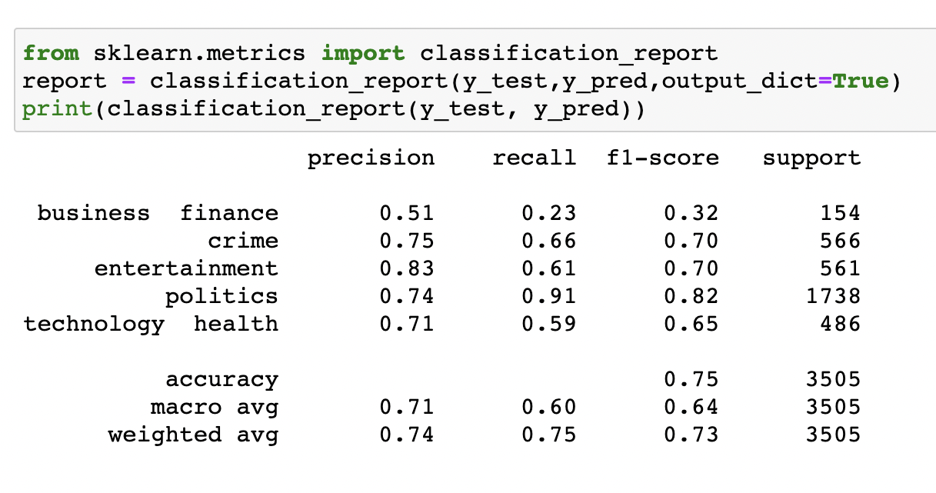

**Results for Random Forest Classifier:**

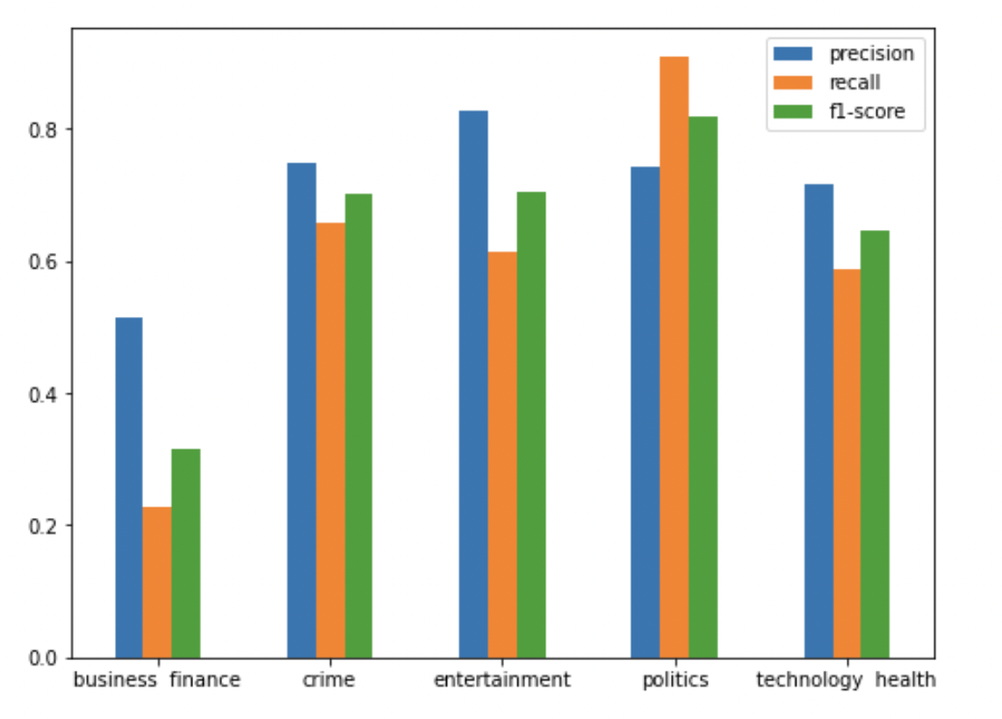

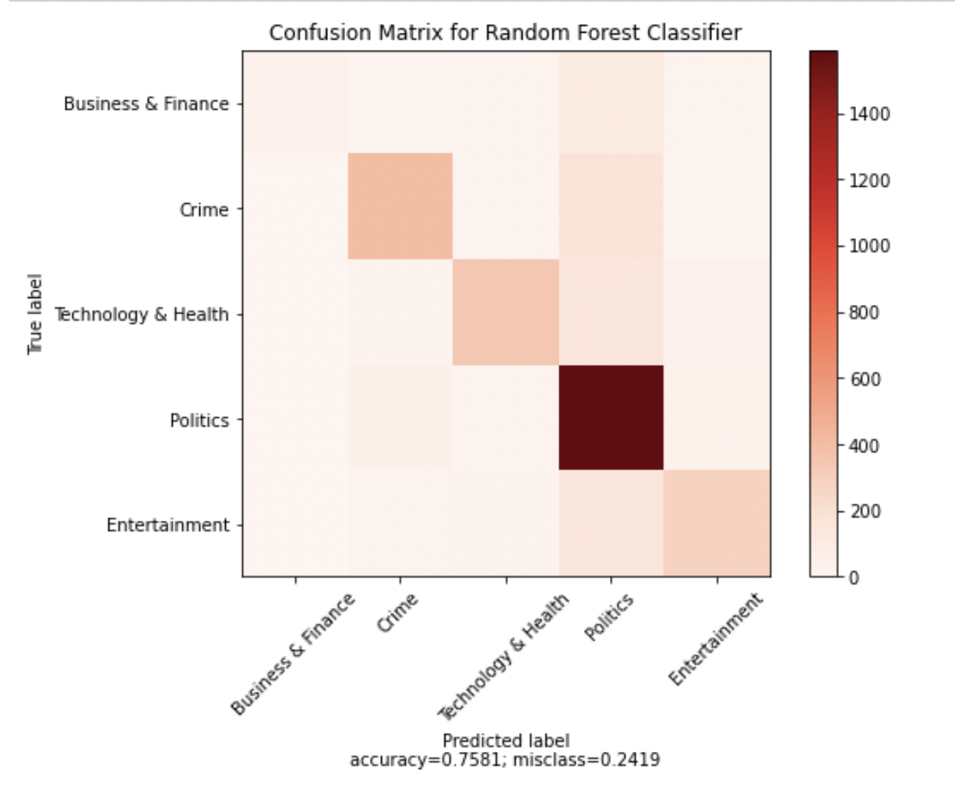

## Support Vector Machine (SVM) Classifier

Backing Vector Machines is a characterization approach, it however can be utilized in the two kinds of order and relapse issues. It can undoubtedly deal with different persistent and absolute factors. SVM develops a hyperplane in multidimensional space to isolate various classes. SVM produces ideal hyperplane in an iterative way, which is utilized to limit a mistake. The center thought of SVM is to track down a most extreme negligible hyperplane (MMH) that best partitions the dataset into classes. Backing vectors are the information focuses, which are nearest to the hyperplane. These focuses will characterize the isolating line better by computing edges. These focuses are more pertinent to the development of the classifier. A hyperplane is a choice plane what isolates between a bunch of articles having diverse class participations. An edge is a hole between the two lines on the nearest class focuses. This is determined as the opposite separation from the line to help vectors or nearest focuses. On the off chance that the edge is bigger in the middle of the classes, it is viewed as a decent edge, a more modest edge is a terrible edge.

Piece stunt assists you with building a more exact classifier.

• **Linear Kernel** - A direct bit can be utilized as expected spot item any two given perceptions. The item between two vectors is the amount of the duplication of each pair of info esteems.

• **Polynomial Kernel** - A polynomial portion is a more summed up type of the direct piece. The polynomial portion can recognize bended or nonlinear information space.

• **Radial Basis Function Kernel** - The Radial premise work bit is a famous bit work generally utilized in help vector machine order. RBF can plan an info space in limitless dimensional space.

### Feature Extraction and Vectorization

The usual vectorization process has been implemented to follow bag of words approach.

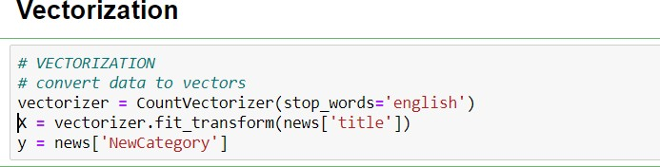

### Splitting the data and Training the model

To start with, we have isolated the sections into needy and autonomous factors (or highlights and name). At that point we have part those factors into train and test set.

### Linear SVM

After splitting, we have generated Support Vector Machine model on the training set and performed prediction on test set features.

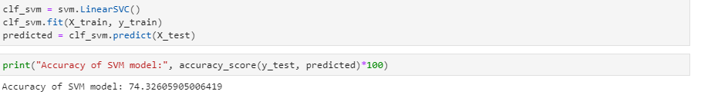

### SVM Using RBF

### 

### 

### SVM Using Polynomial (degree = 3)

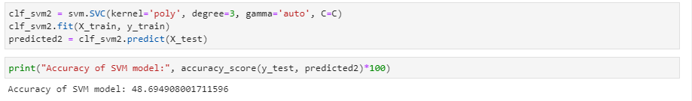

### Evaluating the model

We have evaluated the model using the classification report and confusion matrix. Classification report comprises of categories mapped against the model metrics such as F1 score, Recall, support and Precision.

### Linear SVM

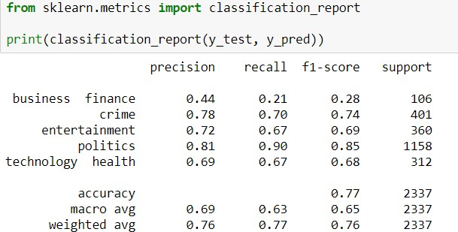

**Results for Linear SVM model:**

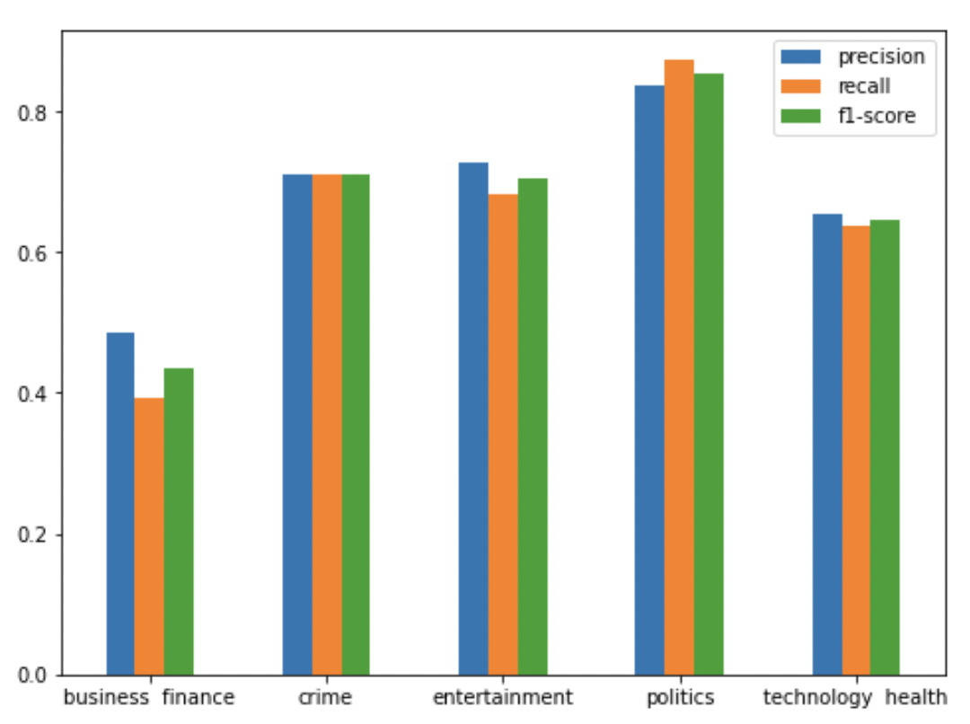

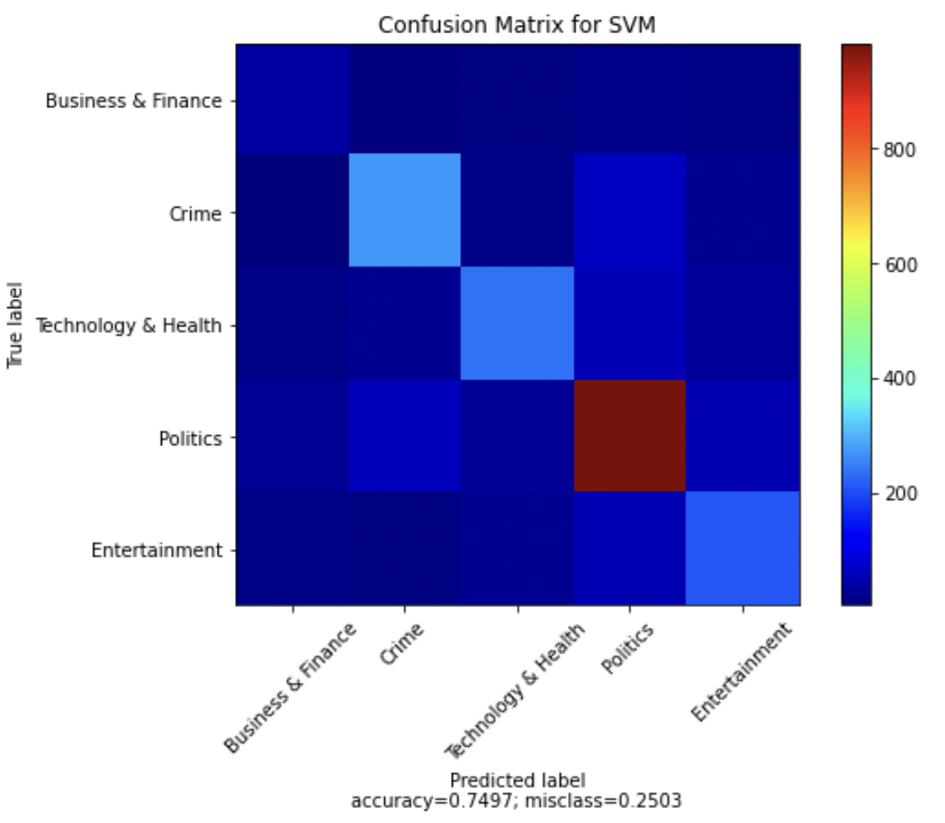

### SVM Using RBF

### 

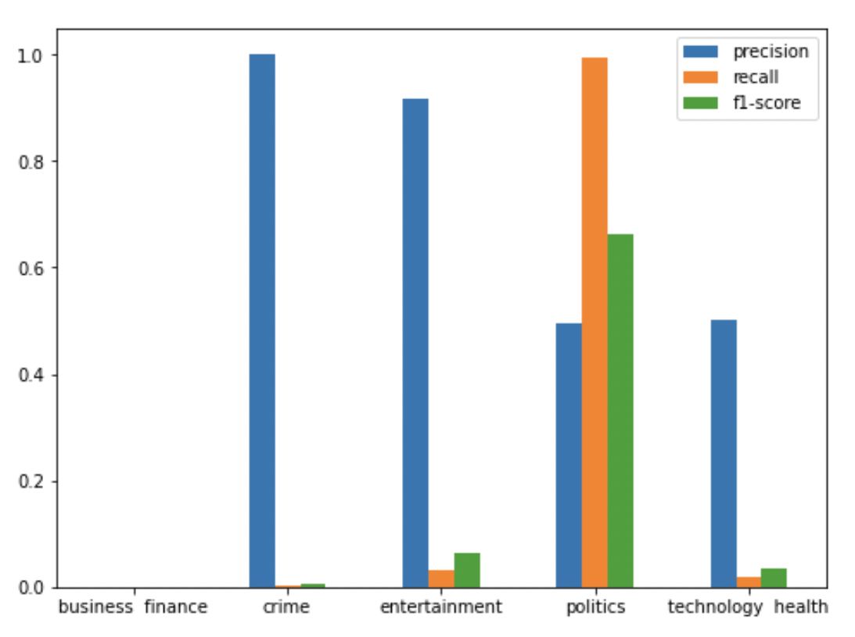

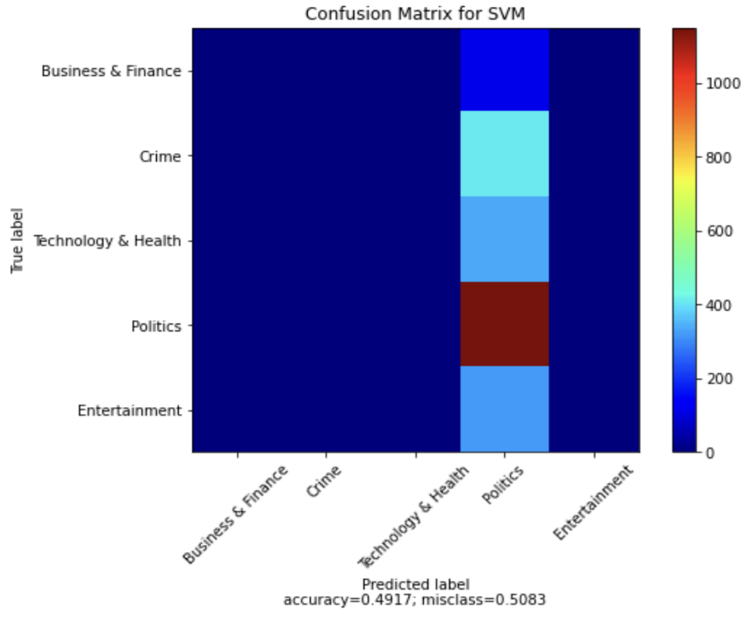

### SVM Using Polynomial (degree = 3)

### 

### 

## K-Nearest Neighbours (KNN) Classifier

In design acknowledgment, the k-closest neighbors calculation (k-NN) is a non-parametric strategy utilized for order. The info comprises of the k nearest preparing models in the component space. In k-NN arrangement, the yield is a class participation. An item is grouped by a majority vote of its neighbors, with the article being appointed to the class generally basic among its k closest neighbors (k is a positive number, regularly little). Assuming k = 1, the article is basically relegated to the class of that solitary closest neighbor.

### Feature Extraction and Vectorization

Rather than various models, Random Forest takes in a numeric worth to perform feature planning. In our endeavor, the first dataset has classes as text regard. To achieve feature planning, we have factorized the Category fragment and changed over them into class ids. A while later, the commonplace vectorization measure has been done to follow sack of words approach.

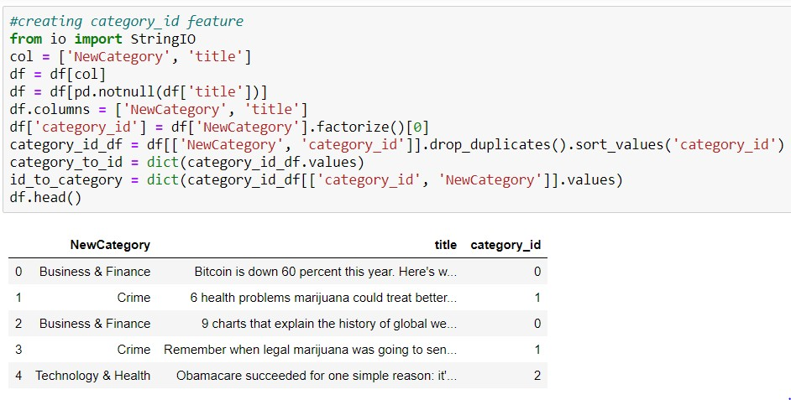

### Splitting the data and Training the model

First, we have separated the columns into dependent and independent variables (or features and label). Then we have split those variables into train and test set.

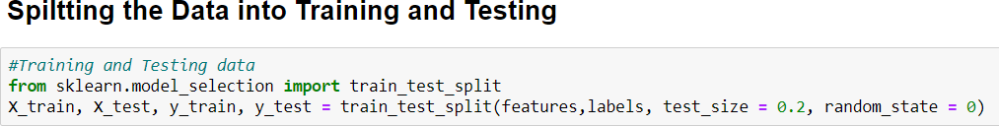

After splitting, we have generated KNN model on the training set and performed prediction on test set features.

**Training the Decision Tree classifier**

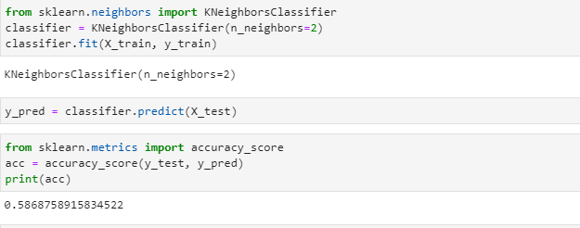

In order to enhance the performance, we would perform hyperparameter tuning. There are a few parameters we implicitly assumed when we did our training. In Random Forest model, n_neighbors is the parameter on which hyperparameter tuning is performed. N_neighbors denotes the number of neighbors to be taken into consideration. In most cases, the best way to determine optimal values for hyperparameters is through a grid search over possible parameter values, using cross validation to evaluate the performance of the model on your data at each value.

**Hyperparameter Tuning**

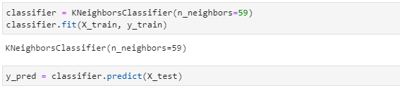

### Evaluating the model

We have evaluated the model using the classification report and confusion matrix. Classification report comprises of categories mapped against the model metrics such as F1 score, Recall, support and Precision.

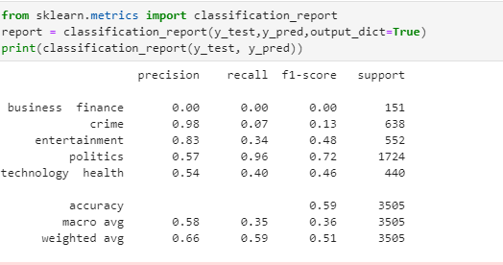

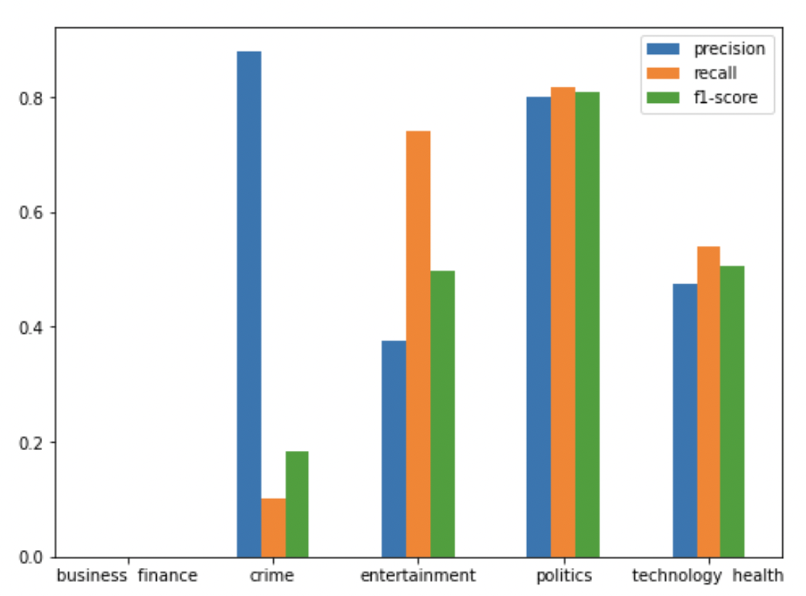

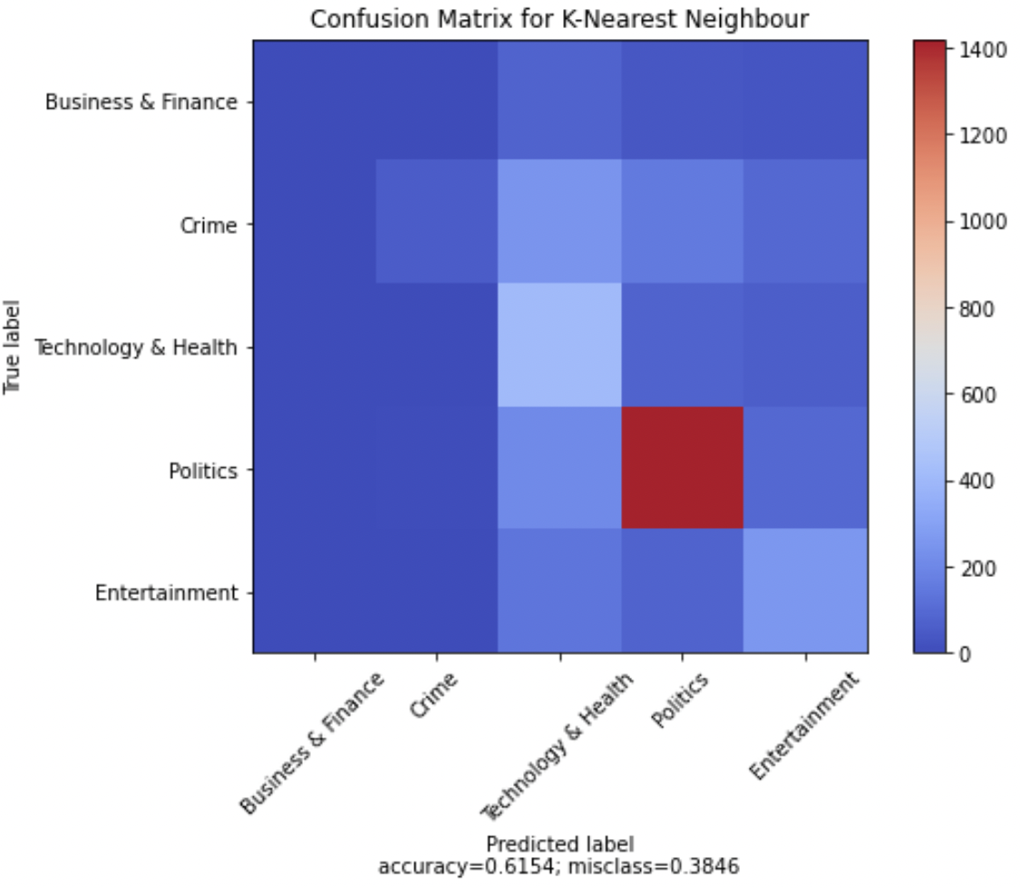

## Stochastic Gradient Descent (SGD) Classifier

In Stochastic Gradient Descent, a couple of tests are chosen haphazardly rather than the entire informational index for every emphasis. In Gradient Descent, there is a term called "cluster" which means the absolute number of tests from a dataset that is utilized for ascertaining the inclination for every emphasis. In run of the mill Gradient Descent streamlining, the cluster is taken to be the entire dataset. Different emphases happen until the minima is reached. The information test is arbitrarily rearranged and chosen for playing out the emphasis.

### Feature Extraction and Vectorization

The usual vectorization process has been implemented to follow bag of words approach.

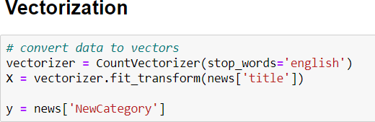

### Splitting the data and Training the model

First, we have separated the columns into dependent and independent variables (or features and label). Then we have split those variables into train and test set.

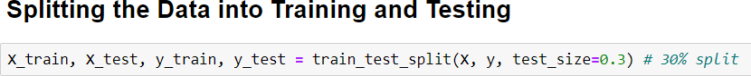

After splitting, we have generated SGD model on the training set and performed prediction on test set features.

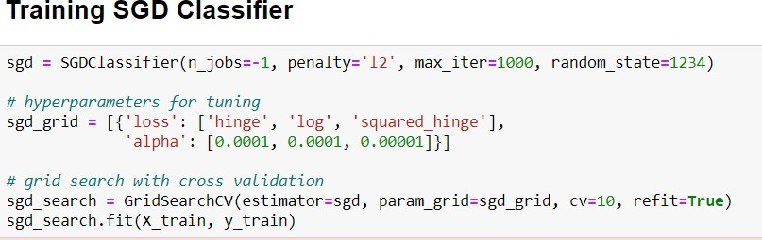

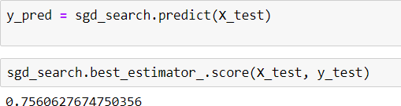

To improve the exhibition, we would perform hyperparameter tuning. There are a couple of boundaries we verifiably accepted when we did our preparation. In SGD model, we have utilized matrix search over conceivable boundary esteems to decide ideal qualities for hyperparameters.

In our model, we utilized changed incentive for misfortune and alpha. Utilizing network search, we confirmed that the best fit for our model.

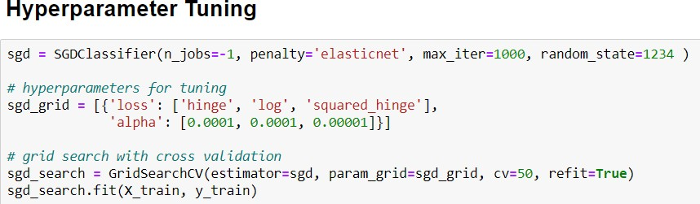

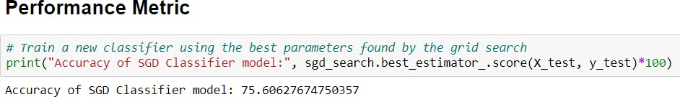

### Evaluating the model

We have evaluated the model using the classification report and confusion matrix. Classification report comprises of categories mapped against the model metrics such as F1 score, Recall, support and Precision.

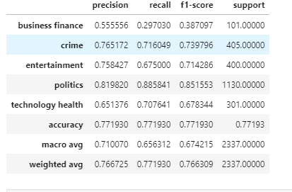

**Results for Stochastic Gradient Descent classifier model:**

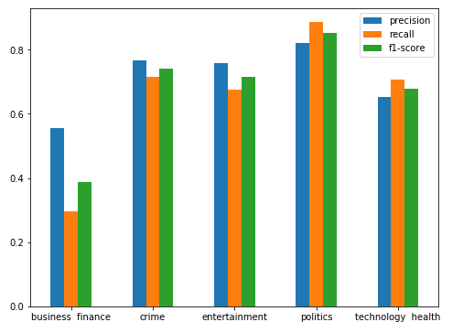

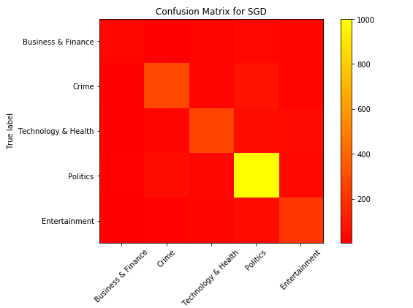

# Specifications of Dataset

The data has been gathered from one of the widely used news site – Vox. Dataset contains news articles published on the Vox news site which cover variety of domains. The link of the dataset can be found below:

[Dataset](https://github.com/adityaNEU/INFO-6105-34274-/blob/main/Dataset.tsv)

The dataset size is just over 74 MB, containing 11,684 rows and 8 columns. There are around 170 categories which could not be considered as core categories. These 170 categories could be grouped into some generic categories. So, we have manually created 5 clusters and added all the related categories in those 5 categories. These are mainly -

* Entertainment
* Health and Technology
* Politics
* Crime
* Business and Finance Dataset contains 8 columns namely,
* **Title**: This column contains the headlines of the news article. This attribute has been used by the system during feature engineering.
* **Author**: This column contains the names of the author of that news article.
* **Category**: Every news is categorized into various news domains based on the article.
* **Published Date**: Contains the date on which the news article was published.
* **Updated Date**: This column displays the latest date on which the news article was recently updated from the time it published.
* **Slug**: This column contains the URL of the news from where this news has been retrieved.
* **Blurb**: This column contains a short description of the news article. We are ignoring this column from the dataset as our system provides a short summary from the news body.
* **Body**: This displays the news description of the article. This column is being used by the system to form a short summary of the article using NLP technique.

# Results and Analysis

In our task we have executed the five AI calculations to arrange the news stories dependent on some pre-characterized classes. In light of our model exhibition and investigation, the Naïve Bayes Classifier models showed the best precision among different models. Gaussian Naïve Bayes classifier could arrange the news stories into classifications with 76.35% exactness. Beneath table shows a combined perspective on exactness and different boundaries for every one of the models.

|  |  |  |  |  |  |
| --- | --- | --- | --- | --- | --- |
| **MODELS** | **ACCURACY** | **PRECISION** | **RECALL** | **F1-SCORE** | **SUPPORT** |
| **Random Forest Classifier** | 75.81 | 0.74 | 0.75 | 0.73 | 3505 |
| **Support Vector Machine Classifier** | 74.37 | 0.76 | 0.77 | 0.76 | 2337 |
| **Multinomial Naïve Bayes Classifier** | 76.35 | 0.76 | 0.76 | 0.76 | 3505 |
| **Stochastic Gradient Descent Classifier** | 75.60 | 0.76 | 0.77 | 0.76 | 2337 |
| **K-Nearest Neighbor Classifier** | 61.54 | 0.66 | 0.59 | 0.57 | 3505 |
| **Gaussian Naïve Bayes Classifier** | 76.26 | 0.75 | 0.75 | 0.75 | 3505 |

# Conclusion & Future Scope

An execution of information grouping and synopsis is offered in this venture. The motivation behind this task was to acquire bits of knowledge into the data recovery field regarding how characterization and outline usefulness functions. Our framework, News Classifier, obliges two arrangements of clients – a news peruser and a news investigator. We have classified the news story dataset with high exactness into classifications like Entertainment, Politics, Crime, Health and Technology and Business and Finance and made important perceptions for the equivalent. We have executed six managed AI arrangement calculations to figure out which of the models had the option to group the news story with the most noteworthy precision rate. We performed information cleaning and information pre-handling to change over crude dataset into a significant and useable dataset. What's more, stop words sifting utilizing recurrence based stop words expulsion approach is likewise carried out. In continuation from the above advance, we performed include designing and model preparing. We upgraded the consequences of the testing dataset by carrying out hyperparameter tuning. We presumed that Gaussian Naïve Bayes Classifier model showed the most noteworthy pace of precision among all the classifier models.

In future these calculations can be tried on bigger dataset. Also, these calculations can be improved so productivity of order could be upgraded. A mix of calculation can be utilized to accomplish

Bunching in a different manner.

# References and resources

1. Classification of News Dataset <http://cs229.stanford.edu/proj2018/report/183.pdf>
2. <http://www.iosrjournals.org/iosr-jce/papers/Vol18-issue1/Version-3/D018132226.pdf>
3. Li, Yanjun, Soon M. Chung, and John D. Holt. "Text document clustering based on frequent word meaning sequences.”, Data & Knowledge Engineering.
4. Luo, Congnan, Yanjun Li, and Soon M. Chung. "Text document clustering based on neighbors.", Data & Knowledge Engineering.
5. Zheng, Hai-Tao, Bo-Yeong Kang, and Hong-Gee Kim. "Exploiting noun phrases and semantic relationships for text document clustering ,179(13) ,2009,2249-2269.
6. Scikit-learn 0.20.0 documentation https://scikit-learn.org/0.20/_downloads/scikit- learndocs.pdf
7. Scikit-learn Text Feature Extraction https://scikitlearn.org/stable/modules/ feature_extraction.html#text-feature-extraction
8. Scikit-learn Support Vector Machine Classifier

https://scikit-learn.org/stable/modules/generated/sklearn.svm.SVC.html

1. Scikit-learn Random Forest Classifier https://scikit- learn.org/stable/modules/generated/sklearn.ensemble.RandomForestClassifier.html
2. Scikit-learn K-Nearest Neighbors Classifier https://scikit- learn.org/stable/modules/generated/sklearn.neighbors.KNeighborsClassifier.html
3. Scikit-learn Stochastic Gradient Descent Classifier https://scikit- learn.org/stable/modules/generated/sklearn.linear_model.SGDClassifier.html
4. Scikit-learn Multinomial Naïve Bayes Classifier https://scikit- learn.org/stable/modules/generated/sklearn.naive_bayes.MultinomialNB.html
5. Introduction to Machine Learning with Python A Guide for Data Scientists by Andreas

C.Müller, Sarah Guido (z-lib.org).pdf

1. <http://sifaka.cs.uiuc.edu/~wang296/Course/IR_Fall/docs/Projects/Samples/6.pdf>
2. https://[www.analyticsvidhya.com/blog/2018/11/introduction-text-summarization-](http://www.analyticsvidhya.com/blog/2018/11/introduction-text-summarization-) textrank/python/